Image | 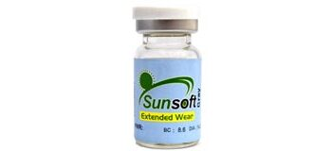
Brand | DIOR
Model Name | SUN SOFT
Price | RS 3000
PRODUCT DETAILS

